OBJECT ORIENTED PROGRAMMING

[CT-260]



NAME: ABDUL RAHEEM SHEIKH

ROLL NO: CT-25192

DEPARTMENT: BCIT

BATCH: 2025

YEAR & SECTION: FSCS-D

LAB: 3

CODES
Q1.
#include <iostream>
#include <cstring>
using namespace std;

class Employee {
private:
char* EmployeeName;
const int EmployeeId; // Cannot be changed after initialization

public:
// Constructor with member initializer list
Employee(const char* name, int id) : EmployeeId(id) {
EmployeeName = new char[strlen(name) + 1];
strcpy(EmployeeName, name);
}

// Destructor
~Employee() {
delete[] EmployeeName;
}

// Getter for name
const char* getEmployeeName() const {
return EmployeeName;
}

// Getter for ID
int getEmployeeId() const {
return EmployeeId;
}

// Setter for name only
void setEmployeeName(const char* name) {
delete[] EmployeeName;
EmployeeName = new char[strlen(name) + 1];
strcpy(EmployeeName, name);
}
};

int main() {
Employee Employee1("Ali", 101);
Employee Employee2("Sara", 102);
Employee Employee3("Jhon", 103);

Employee1.setEmployeeName("Ahmed");

cout << "Employee 1: " << Employee1.getEmployeeName()
<< ", ID: " << Employee1.getEmployeeId() << endl;

cout << "Employee 2: " << Employee2.getEmployeeName()
<< ", ID: " << Employee2.getEmployeeId() << endl;

cout << "Employee 3: " << Employee3.getEmployeeName()
<< ", ID: " << Employee3.getEmployeeId() << endl;

return 0;
}

Q2.
#include <iostream>
using namespace std;

class DynamicArray {
private:
int* arr;
int capacity;
int currentSize;

public:
DynamicArray(int size) {
capacity = size;
currentSize = 0;
arr = new int[capacity];

for(int i = 0; i < capacity; i++)
arr[i] = 0;
}

~DynamicArray() {
delete[] arr;
}

void push(int value) {
if(currentSize < capacity) {
arr[currentSize++] = value;
} else {
cout << "Array is full!" << endl;
}
}

int size() const {
return currentSize;
}

void display() const {
for(int i = 0; i < currentSize; i++)
cout << arr[i] << " ";
cout << endl;
}
};

int main() {
DynamicArray obj(5);
obj.push(10);
obj.push(20);
obj.push(30);

obj.display();
cout << "Size: " << obj.size() << endl;

return 0;
}

Q3.
#include <iostream>
using namespace std;

class Account {
private:
int account_no;
double account_bal;
int security_code;

static int count;

public:
void initialize(int no, double bal, int code) {
account_no = no;
account_bal = bal;
security_code = code;
count++;
}

void display() const {
cout << "Account No: " << account_no << endl;
cout << "Balance: " << account_bal << endl;
cout << "Security Code: " << security_code << endl;
}

static int getCount() {
return count;
}
};

int Account::count = 0;

int main() {
Account a1, a2;

a1.initialize(1001, 5000.75, 1234);
a2.initialize(1002, 7000.50, 5678);

a1.display();
a2.display();

cout << "Total Accounts Created: " << Account::getCount() << endl;

return 0;
}

Q4.

#include <iostream>
using namespace std;

class Student {
private:
string name;
const int rollNumber; // Cannot change
float gpa;

public:
Student(string n, int r, float g) : rollNumber(r) {
name = n;
gpa = g;
}

void setGPA(float g) {
gpa = g;
}

float getGPA() const { // const member function
return gpa;
}

int getRollNumber() const {
return rollNumber;
}

void display() const {
cout << "Name: " << name << endl;
cout << "Roll Number: " << rollNumber << endl;
cout << "GPA: " << gpa << endl;
}
};

int main() {
Student s1("Ali", 101, 3.5);
s1.setGPA(3.8);
s1.display();
return 0;
}

Q5.
#include <iostream>
using namespace std;

class HotelMercato {
private:
string customerName;
int days;
static const double rentPerDay; // Fixed rent decided by committee
double totalRent;

void calculateRent() {
if(days > 7)
totalRent = (days - 1) * rentPerDay;
else
totalRent = days * rentPerDay;
}

public:
HotelMercato(string name, int d) {
customerName = name;
days = d;
calculateRent();
}

void display() const { // Cannot modify data
cout << "Customer Name: " << customerName << endl;
cout << "Days: " << days << endl;
cout << "Rent: " << totalRent << endl;
}
};

const double HotelMercato::rentPerDay = 1000.85;

int main() {
HotelMercato c1("Ahmed", 5);
HotelMercato c2("Sara", 10);

c1.display();
cout << endl;
c2.display();

return 0;
}

OUTPUTS

Q1.
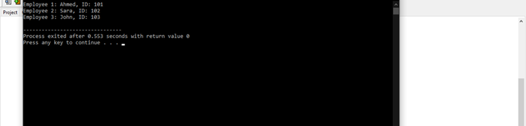

Q2.
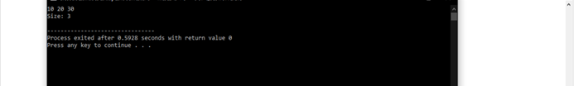

Q.3
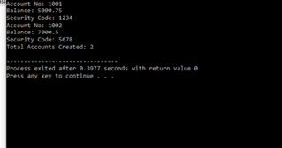

Q4.
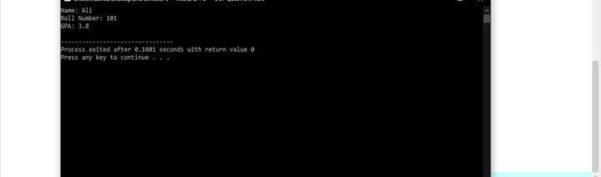

Q5.

